LIBSPACE
(React Application)







GOVERNMENT ARTS AND SCIENCE COLLEGE
WIMCO NAGAR
THIRUVOTTIYUR ,CHENNAI-19

LIBSPACE

Team ID: SWTID-2026-1617

Team Size: 4

Team Leader: SNEHA S
Team Member: THILOTHAMMA B
Team Member: VINODHA S
Team Member: VANAJA A

INDEX

- PROJECT TITLE
- INTRODECTION
- RUNNING DEVELOPING
- FEATURES
- ROLES AND RESPONSIBILITIES
- BACKEND DEVELOPMENT
- DATABASE DEVELOPMENT
- OUTPUT SCREENSHOTS
- USER REGISTRATION OUTPUT
- USER LOGIN OUTPUT
- ADDING BOOK
- GET ALL BOOK
- GET BOOK BY ID
- UPDATE BOOK
- DELETE BOOK
- USER LOGOUT

Project Title
Libspace API - A Robust Backend for Library Operations.

- Instructions – LibSpace

- Register a new user account using the registration form.
- Log in with the registered credentials to access the dashboard.
- After successful login, perform book management operations:
  - Add a new book.
  - View the list of available books.
  - Get book by ID
  - Update book details.
  - Delete a book.
- Users can log out securely after completing operations.
- Users also have the option to delete their account permanently from the system.
These instructions describe how the system should be used once it is running.

- Running Developing:

Before running or developing LibSpace, ensure the following:
- Basic knowledge of:
  - JavaScript
  - Backend concepts (e.g., Node.js / Express)
  - Database fundamentals (CRUD operations)
- Software Requirements:
  - Node.js and npm installed
  - Database setup (MongoDB / MySQL)
  - Code editor (e.g., VS Code)
  - Web browser (Chrome/Firefox)

- Basic understanding of:
  - REST APIs
  - Authentication (sessions or JWT)
  - Environment variables configuration

Features:
1. User Authentication

- User Registration (name, email, password)
- Secure password storage (hashed password)
- User Login with credential verification
- Token-based authentication (JWT)
- Delete User Account
- Automatic timestamps (createdAt, updatedAt)

2. Book Management (CRUD Operations)

Each book is linked to a specific user using a reference (user: ObjectId).
- Add a new book (url, title, author)
- Get all books of a specific user
- Get book by ID
- Update book details
- Delete a book
- Books are protected and accessible only to the authenticated user

- User–Book Relationship

- One-to-Many Relationship:
  - One User → Can have multiple Books
  - Each Book → Belongs to one User (via ObjectId reference)

- Security & Validation

- Input validation for required fields
- Protected routes using authentication middleware
- Error handling for invalid requests
- Unauthorized access prevention

- RESTful API Design

- Follows REST principles
- Uses standard HTTP methods:
  - POST
  - GET
  - PUT
  - DELETE
- Returns structured JSON responses

Roles and Responsibilities:
Requirement Analysis

- Understanding project requirements (authentication + book CRUD).
- Designing database schema for Users and Books.
- Defining relationship between User and Book (One-to-Many).

Database Design

- Creating Mongoose schemas:
  - User Schema (name, email, password, timestamps)
  - Book Schema (url, title, author, user reference)
- Establishing ObjectId reference between Book and User.
- Ensuring data consistency and integrity.

API Development

- Developing RESTful API endpoints.
- Implementing:
  - User Registration
  - User Login
  - Delete User
  - Add Book
  - Get Books
  - Update Book
  - Delete Book
- Structuring routes and controllers properly.

Authentication & Security

- Implementing password hashing (bcrypt).
- Generating JWT tokens for authentication.
- Protecting private routes using middleware.
- Handling unauthorized access and validation errors.

Error Handling & Validation

- Validating required fields.
- Handling invalid credentials.
- Managing database errors.
- Returning structured JSON responses.

Testing & Debugging

- Testing APIs using Postman.
- Verifying CRUD operations.
- Fixing bugs and ensuring proper response status codes.
Backend Development

The backend of LibSpace is developed using Node.js and Express.js, following RESTful architecture principles. It handles authentication, business logic, database operations, and API responses. The backend ensures secure data handling, structured routing, and efficient communication with MongoDB.
1️⃣ API Development & Routing
The backend APIs are built using Express.js. Routes are structured into separate files for user and book operations to maintain modularity.
- User Routes handle:
  - Registration
  - Login
  - Logout
  - Delete User
- Book Routes handle:
  - Add Book
  - Get Books
  - Update Book
  - Delete Book

2️⃣ Database Integration & Authentication

MongoDB is used as the database, integrated using Mongoose for schema modeling and data management.
- User passwords are securely hashed using bcrypt.
- JWT (JSON Web Token) is generated during login for authentication.
- Protected routes use middleware to verify tokens.
- A blacklist collection is maintained to invalidate tokens during logout.
This ensures secure access control and efficient data management within the backend system.

DATABASE DEVELOPMENT:

The database for LibSpace is developed using MongoDB, a NoSQL document-based database.
The application stores two main collections:
- Users
- Books
A one-to-many relationship is maintained:
- One User → Can have multiple Books
- Each Book → Belongs to one User (via ObjectId reference)
MongoDB stores data in JSON-like documents, making it flexible and scalable.

Output Screenshots:
Output on terminal once server starts:

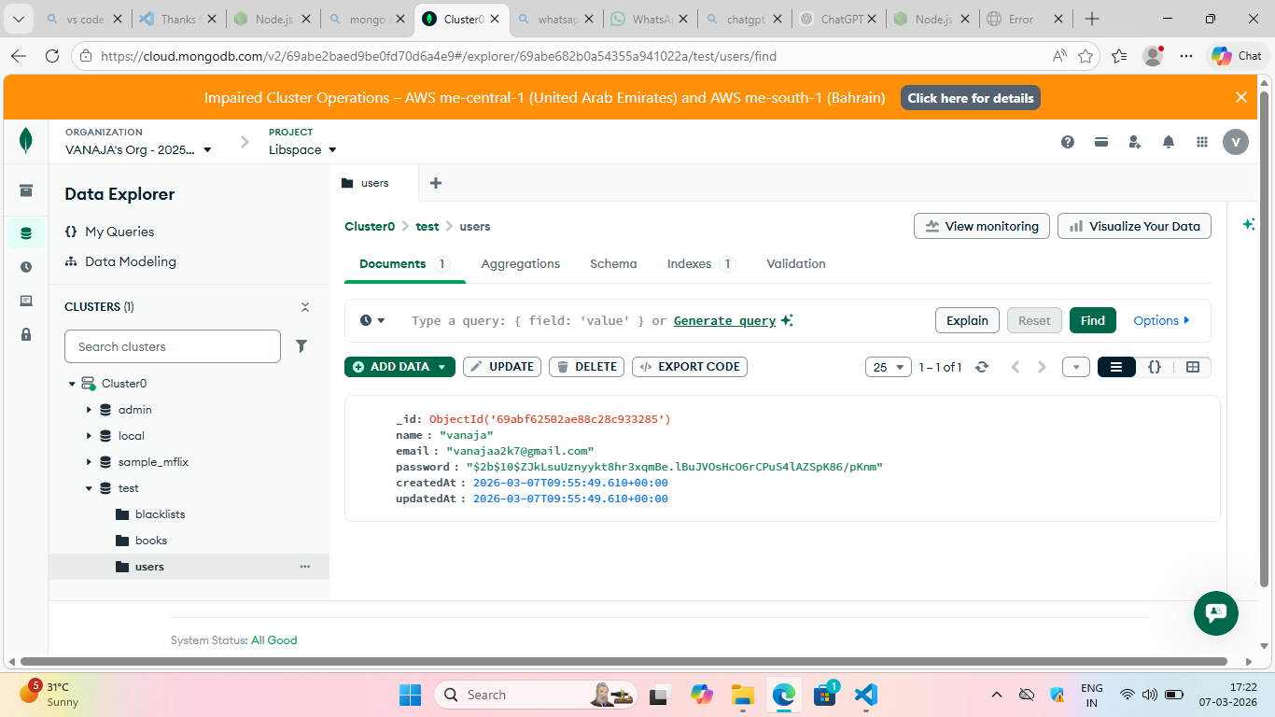

User registration output:

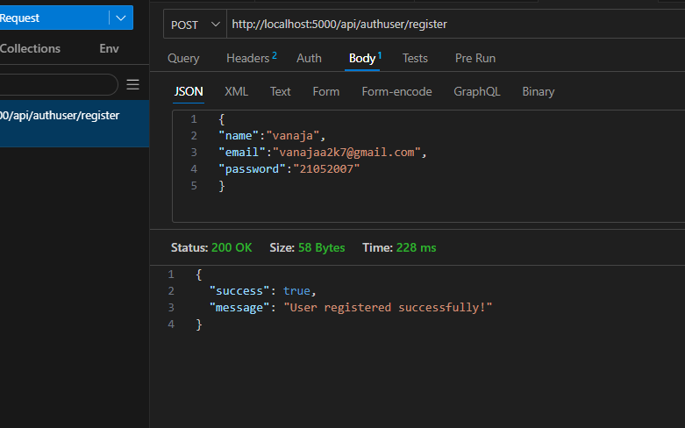

User Login output:

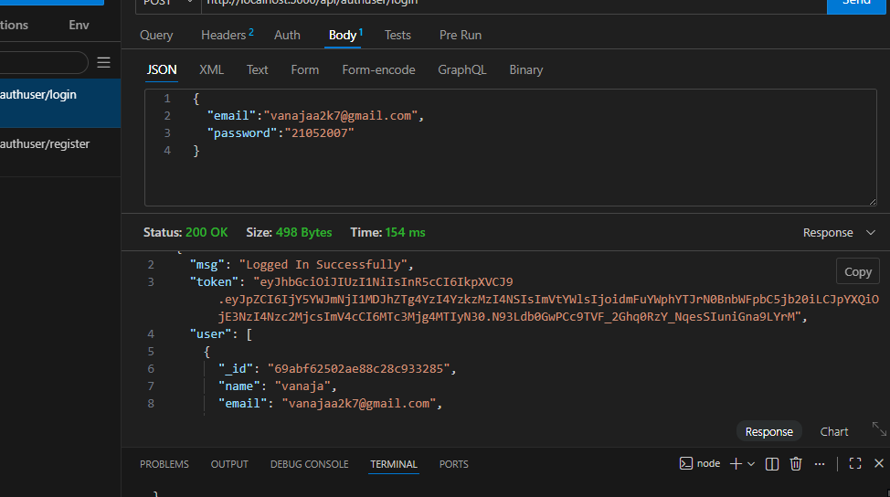
Adding book:

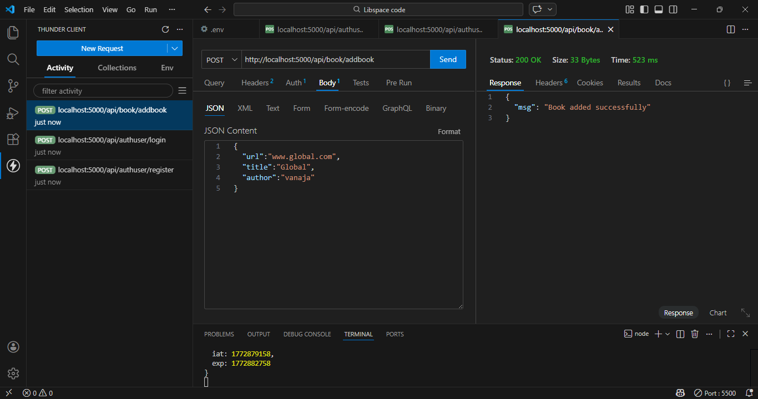

Get All books:

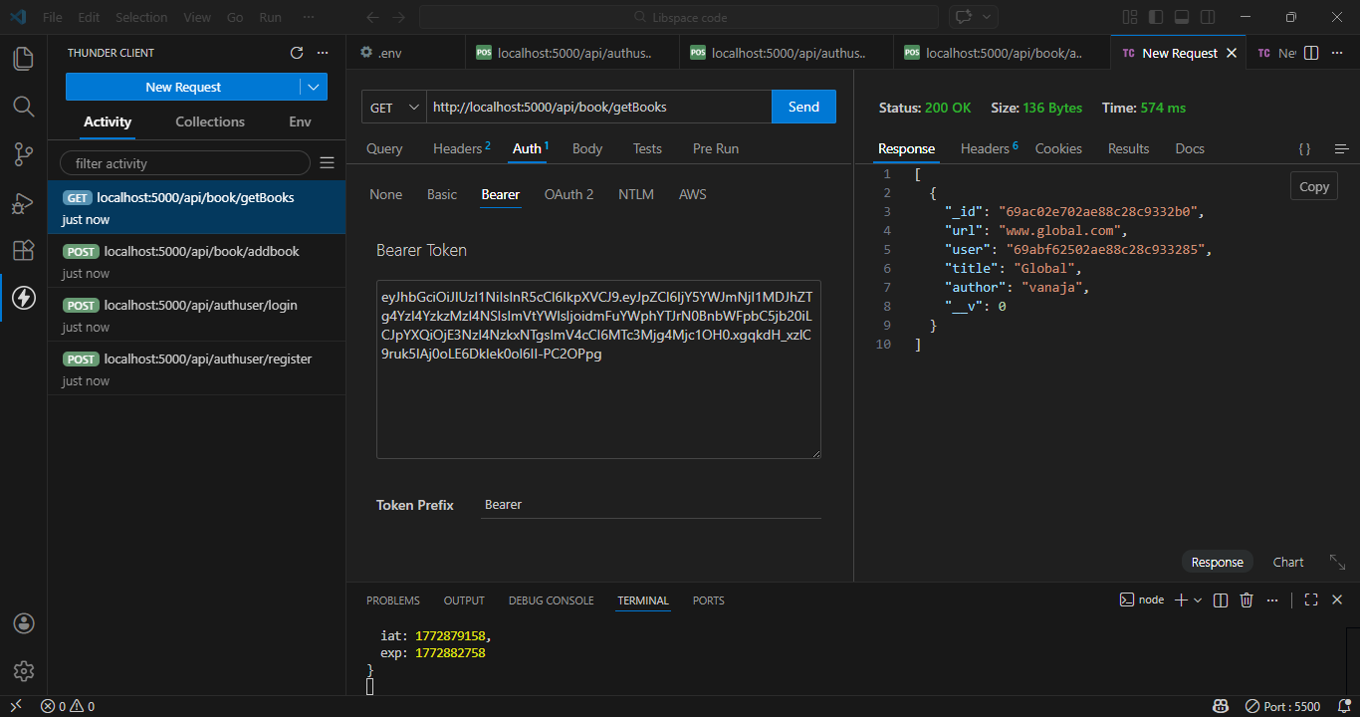

Get book by ID:

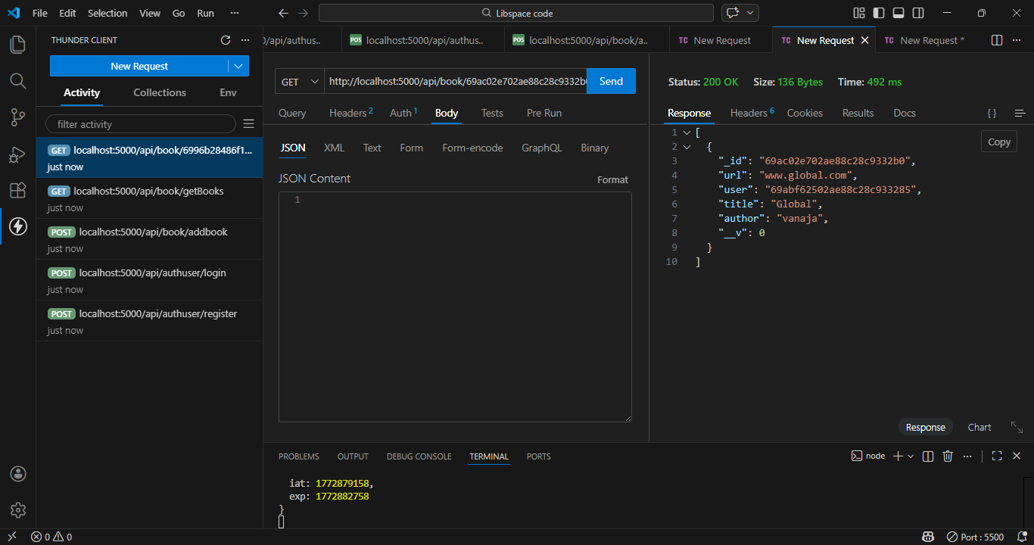

Update book:
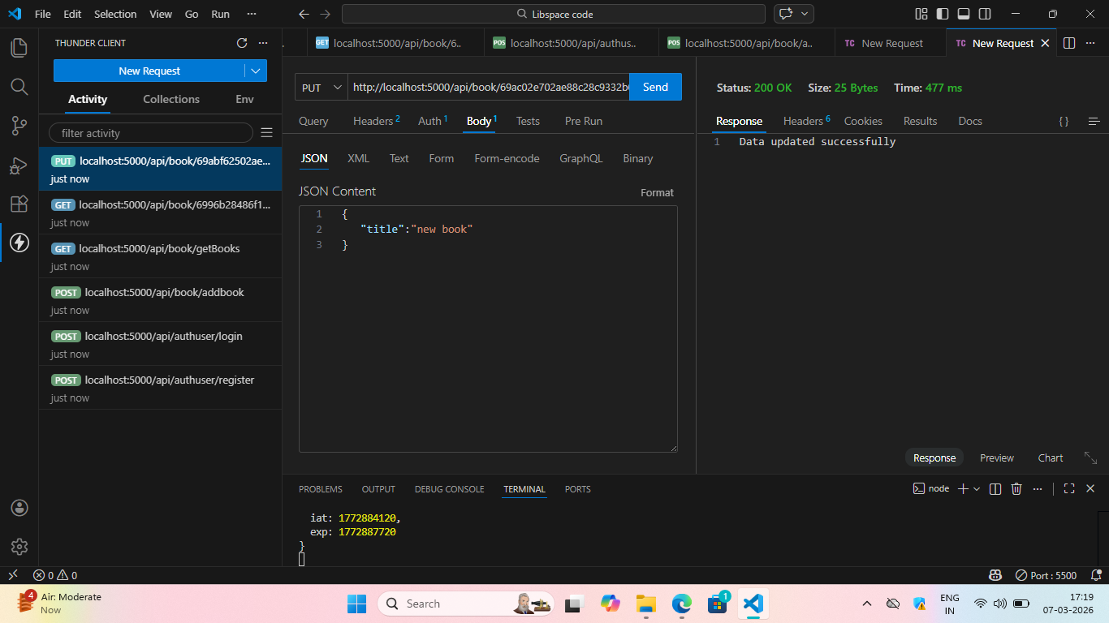

Delete book:
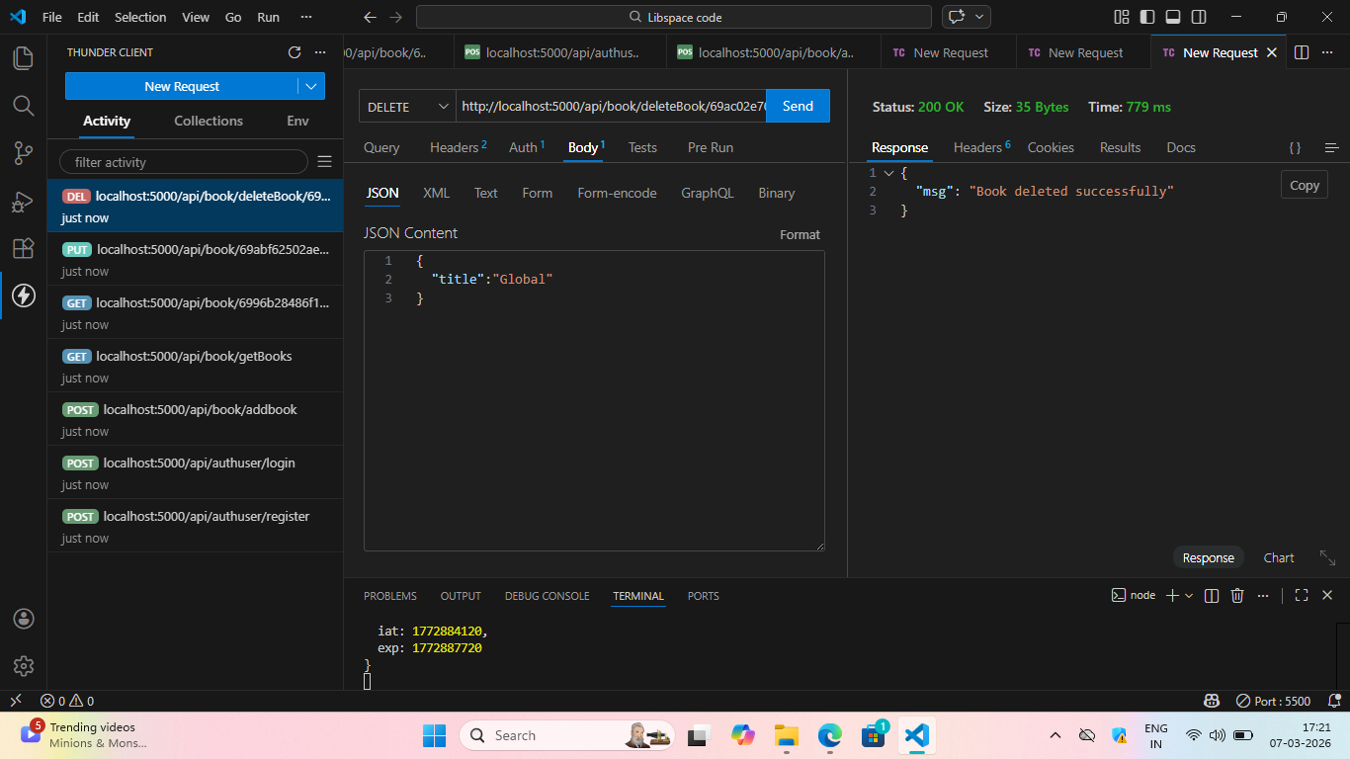

User Logout:
